MED D - Test Claim - Processing with Inactive NDC

Process
Related Documents

Description: This document is when a pharmacist is calling in and processing with an inactive NDC.

Process

Perform the steps below:
Step | Action
1 | Select the inactive box in PeopleSafe in the Drug Lookup Screens and in the Test Claim Screens for the drug to display.  Note: The inactive box is the only one that is not auto-populated automatically in PeopleSafe today. In these instances, Test Claims need to be accomplished using the inactive NDC.  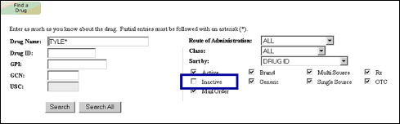  For additional information on Inactive NDCs, refer to Inactive NDC.

Top of the Document

Related Documents
MED D - Test Claim Index

Parent SOP: CALL-0048: Medicare Part D Customer Care Call Center Requirements-CVS Caremark Part D Services, L.L.C.
Abbreviations/Definitions: Abbreviations / Definitions

Top of the Document
Not to Be Reproduced or Disclosed to Others without Prior Written Approval
ELECTRONIC DATA = OFFICIAL VERSION – PAPER COPY – INFORMATIONAL ONLY

